|  |  |  |
| --- | --- | --- |
| S:\MNHS-SPHPM-CORE\CORE\__BARIATRIC SURGERY REGISTRY\CV's, LOGO AND SIGNATURES\LOGOS\BSR LOGO\smith_bsr_logo_design_369036_V1.5sa final.jpg  Bariatric Surgery Registry Newsletter |  |  |
|  |  |  |
| Issue # 1 |  | In This Issue |

**Welcome**

Welcome to the first edition of the Bariatric Surgery Registry (BSR) Newsletter! We plan to send you regular updates of the progress of the BSR as it rolls out across Australia and New Zealand.

The BSR will only achieve its aim of improving the quality and safety of bariatric surgery in our countries with your support. Therefore, it is important that you see the data we are collecting and the information we provide back as useful, and we welcome any feedback, good or bad, as we strive to improve our processes.

In this edition of the newsletter we will give you an overview of the history of the BSR, an update of our current status, as well as introduce you to some of our BSR staff that you will get to know as the registry rolls out.

**Background**

The BSR was developed in response to calls from clinicians for a resource that would track outcomes from bariatric surgery across our community, ensuring the quality and safety of these procedures.

The Obesity Surgery Society of Australia and New Zealand (OSSANZ) took the leadership role in developing

the Registry, and in 2009, after a tender process, appointed the Monash University School of Public Health and Preventative Medicine as custodians.

After receiving seed funding from OSSANZ and Industry, the pilot commenced in 2012, overseen by the steering committee. On the back of the pilot data, the Registry received seed funding from the Commonwealth.

In 2014 the pilot data and registry methodology was confirmed, and the national roll-out began.

**Aims**

The primary aim of the registry is to track and monitor the quality and safety of bariatric surgery. The stated aims of the Registry are to:

1) Record the immediate safety of bariatric surgery in Australia and New Zealand

2) Study longitudinally the safety and efficacy of bariatric surgery in Australia

• Procedure

• Devices

• Complications

• Re-operations

**Welcome**

**Background**

**Aims of the registry**

**Progress update**

**Meet our Staff**

**News/Events**

**Contact Us**

**Thanks to our current sponsors:**





****

3) Track key health changes following bariatric surgery

• Weight change

• Diabetes

To conclude, the registry will gather and collate information on patient weight loss as well as monitor changes in diabetes status and record any problems related to the surgery.

**Roll out update**

We are steadily moving forward with the registry roll-out and currently have 30 hospital sites on board. As each site requires ethics approval, and each site has their own rules and regulations to adhere to, obtaining ethics approval can often be a timely process.

We’d like to thank the clinicians for their patience throughout this process. Please know that we are doing all we can to get your sites approved as quickly as possible. In saying that if you have any questions relating to the progress of your site or you simply want to express interest in the registry please feel free to contact us, our contact information is at the base of this newsletter.

Despite the challenges gaining ethics approval, the registry has managed to secure 30 sites in 2014 with an expected growth of 50 sites by May 2015 and the momentum is clearly gathering pace.

We anticipate the roll-out to New Zealand in 2015 and we will keep you posted of the progress in issue 2 of the newsletter

|  |  |  |  |
| --- | --- | --- | --- |
| **State** | **Approved Sites** | **Sites In progress** | **Sites Remaining** |
| NSW | 4 | 2 | 35 |
| NT | 0 | 1 | 0 |
| QLD | 4 | 5 | 15 |
| SA | 3 | 4 | 4 |
| TAS | 3 | 1 | 1 |
| VIC | 13 | 10 | 20 |
| WA | 3 | 4 | 4 |
| ACT |  |  | 2 |
|  | **30** | **27** | **79** |

|  |  |
| --- | --- |
| **Patients enrolled** | **2647** |
| **Opt-off rate** | **2.8%** |

**Meet our Staff**

**Associate Professor Wendy Brown MBBS (hons) PhD FRACS FACS**

Director, Centre for Obesity Research and Education (CORE)

Clinical Lead, Bariatric Surgery Registry

E: [wendy.brown@monash.edu](file:///C:\Users\charityb\AppData\Local\Microsoft\Windows\Temporary%20Internet%20Files\Content.IE5\SCYSIN8W\wendy.brown@monash.edu)



Associate Professor Wendy Brown is the Director of the Centre for Obesity Research and Education (CORE). Her areas of expertise include: laparoscopic adjustable gastric banding procedures, the effects of weight loss on health and upper gastrointestinal surgery with a primary focus on oesophagogastric junction and obesity.

She serves the broader medical community in a wide variety of roles.

She is currently Immediate Past President of the Obesity Surgery Society of Australia and New Zealand, and Vice President of the Australia and New Zealand Oesophagogastric Surgical Association (ANZGOSA).  She is a deputy senior examiner on the Royal Australasian College of Surgeons (RACS) General Surgery court of examiners and has been a member of the Victorian Surgical Consultative Council.  She has previously been a member of the Victorian State

**Margaret Anderson BHIM, Grad.Dip. HA**



Data Manager, Centre for Obesity Research and Education (CORE) &, Bariatric Surgery Registry  
E: [margaret.anderson@monash.edu](mailto:margaret.anderson@monash.edu)

Margaret joined the Monash University Department of Surgery in March 1999 as Data Manager, involved in bariatric database design & development, and ongoing data collections in the area of bariatric surgery & clinical trials.  Prior to this, Margaret worked in the Department of General Surgery (Alfred Hospital) involved in the design & development of Access-based database systems for the collection of surgical statistics and the provision of an electronic discharge summary to referring doctors.  Prior to this Margaret was employed in Radiation Oncology (WBRC at Alfred Hospital) - clinical trials, breast cancer database and the regular provision of up-to-date survival statistics for Department audits.

Margaret has worked in the area of health information services since 1978, completing a Bachelor of Health Information Management and Graduate Diploma of Health Administration (Lincoln Institute).  She has held various roles in medical record management and the change-over to electronic database systems at The Alfred Hospital since 1981.

**Brittany Smith B.Sc., MPH**

Research Assistant-Bariatric Surgery Registry  
E: [brittany.smith@monash.edu](mailto:brittany.smith@monash.edu)

Brittany is from Philadelphia, PA, USA. She completed a Bachelor of Science in January 2011 at Saint Joseph's University and moved to Australia in July 2011. She has completed a Master of Public Health from the University of Melbourne with specialisation in Health and Social Sciences. Brittany has an interest in health program management and has been responsible for the implementation of the nationwide role out of the national Bariatric Surgery Registry.

**Dianne Brown BEc (Hons)**Business Manager- Bariatric Surgery Registry

E: [dianne.brown@monash.edu](mailto:dianne.brown@monash.edu)

Dianne is currently acting as the business manager for the Bariatric Surgery Registry.  Dianne has worked as a management consultant, specializing in strategy, for 20 years in Australia, Asia and Europe.  She has worked with some of the world’s largest banks, manufacturers and service companies in the areas of costing, strategic marketing, portfolio analysis and market entry strategy.    
   
More recently Dianne has been involved with not-for-profits and public institutions in the areas of education, publishing, welfare provision and health.  At the BSR, Dianne’s key responsibility is to develop a business model that will sustain the registry in the long term.

**Charity Bowen BA Grad.Dip**



Administration Assistant - Bariatric Surgery Registry   
E: [charity.bowen@monash,.edu](mailto:charity.bowen@monash,.edu)

Charity is the Administration Officer for the Bariatric Surgery Registry.

Charity’s administration expertise stems from administrative roles in Government, finance, legal and educational sectors. Most recently, Charity worked in Sales as a Personal Assistant and in the events sector for a nationally recognised and successful company. Charity’s academic achievements include, completing a Bachelor of Arts at La Trobe University and later a Diploma of Education at Monash University.

**Jazmin Padarath**

Data Entry Assistant- Bariatric Surgery Registry   
E: [jazz.padarath@monash.edu](mailto:jazz.padarath@monash.edu)

Jazmin is currently pursuing a Bachelor of Arts and Science at Deakin University. Jazmin assists the registry staff with ongoing data entry tasks.

**Information nights**

As the BSR rolls out across Australia, we have been offering surgeons and other interested staff the opportunity to attend information evenings. So far, these information sessions have been held in Western Australia, South Australia, and Victoria.

The aim of the information sessions is to familiarize hospital staff and surgeons with the registry and its aims as well as provide an opportunity for contributors to ask questions and clarify our processes. In addition, these events have also been a great chance for the registry staff to meet those of you around the country that are involved with Bariatric Surgery, as well as say thank you to those already contributing.

These evenings have proven to be very successful with surgeons and guests providing us with very positive feedback via an online evaluation form. In the near future we hope to touch base with surgeons and hospital staff in the Northern Territory, Queensland and Tasmania and we will keep you posted with all updates and successes.

**CME Approval of the BSR by RACS**

The Registry has also been approved as a Continuing Medical Education (CME) activity by the Royal Australasian College of Surgeon’s (RACS). Fellows contributing to the Registry can claim this activity in Category 1 (audit and peer review).

**Introduction of Dr Monira Hussain**

**We would like to give a warm welcome our newest team member, Dr Monira Hussain, a Research Fellow who joined the registry in late October.**



**Monira completed her m**edical training and went on to complete a Masters of Public Health and more recently a PhD. These academic achievements triggered her interest in epidemiology of obesity, cardiovascular disease, osteoarthritis and diabetes mellitus. Monira has also been involved in large surveys and cohort studies. In 2011 Monira was awarded the prestigious Endeavour International Postgraduate Research Scholarship (IPRS), Australian Postgraduate Award (APA) and as a top student of the Faculty of Medicine, Nursing and Health Sciences and was awarded the Faculty of Excellence Award. This is just a snippet of Monira’s achievements and we have no doubt Monira will achieve even more during her work with the Bariatric Surgery Registry and we welcome her expertise and knowledge.

**Ossanz Meeting 2014 Wellington**

In mid-November, registry staff attended the annual Obesity Surgery Society of Australia and New Zealand (OSSANZ) conference held in Wellington, NZ.

The OSSANZ Conference was a great opportunity for registry staff to liaise with surgeons and also build and develop client relationships with medical device organization’s and others interested in the registry. Likewise, it was an opportunity to exchange ideas, answer questions and hopefully promote and educate people about the success and importance of this initiative.

We enjoyed meeting those of you who popped by our booth and look forward to seeing you all in Hamilton Island next year!

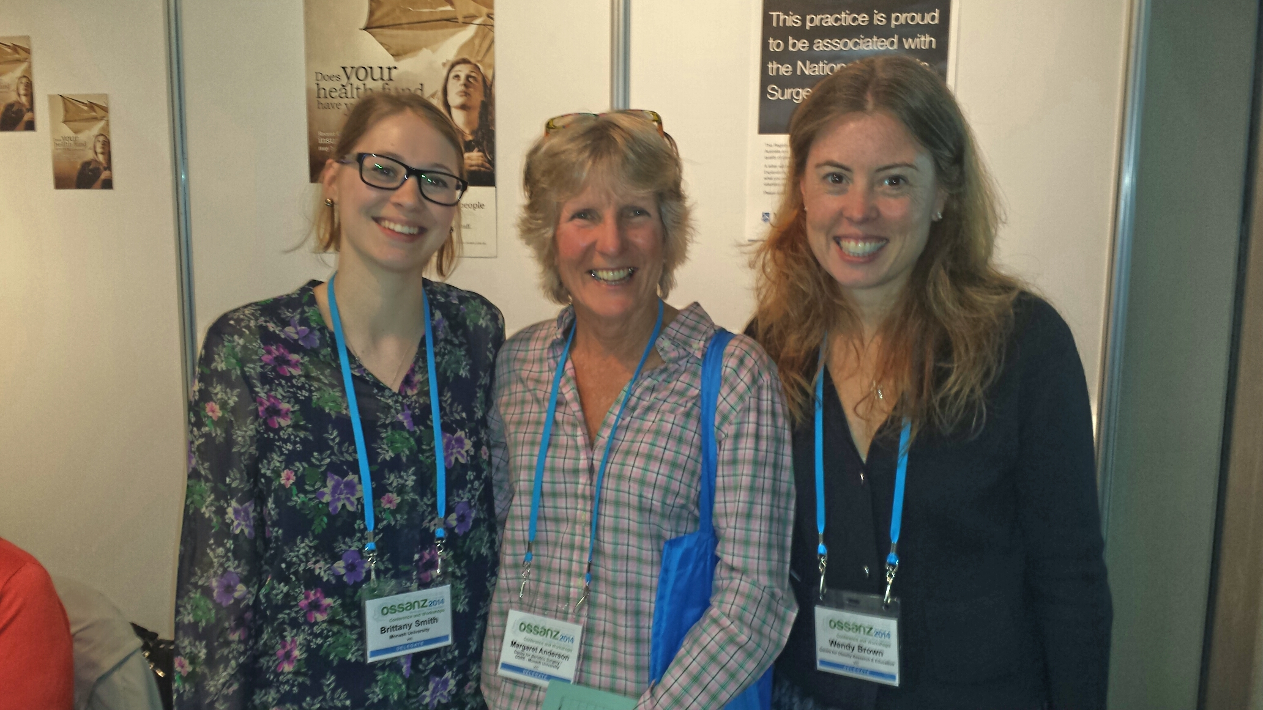

**Did you know?**

The Patient Explanatory statement is now available in 5 languages. If you need patients to be sent the information in a language other than English, please let us know.

Similarly if you need flyers or posters in languages other than English, let us know and we can have these provided to your practice.

**Thank you**

We hope you have enjoyed reading the first issue of the BSR quarterly newsletter we look forward to continued contact and keeping you informed about the progress of the registry

**Contact Us:**

Charity Bowen

Administration Assistant

**E:** [med.bsr@monash.edu](mailto:med.bsr@monash.edu) **A:** Level 6, 99 Commercial Road, Melbourne VIC 3004

**T:** 03 9903 0725 **F:** 03 9903 071