Introduction

The brain or the Encephalon is possibly the most complex organ to examine within the human body. Although only weighing approximately 1,300g in the average adult, all behaviours, actions, thoughts and feelings originate from billions of neural networks interacting to create what we recognise as human. Without the brain our bodies simply would not function, making it important to have an understanding of its structure and function and the implications of diagnosis and pharmacology associated with mental illness. This topic reviews the information needed for a basic understanding of neuro-anatomy including the central nervous system, blood brain barrier, mechanisms for synaptic transmission and functions of the major neurotransmitters.

Brain Structure and Function

Forebrain

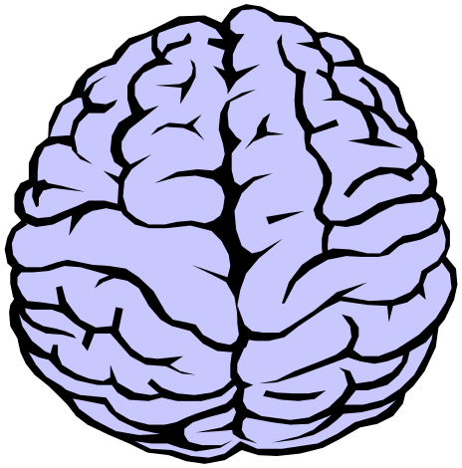

Telencephalon (cerebrum)

The cerebrum is the largest part of the brain and fills the entire upper portion of the cranium. It consists of the 2 cerebral hemispheres and sits atop of and surrounds the brainstem leading to the spinal cord. The cortex (the outer layer of the cerebrum) consists of 80% of the entire brain.

When looking at the brain, what is distinctive is the numerous folds that give it its wrinkled appearance. This folding together of brain tissue allows for greater amount of cerebral surface area (approx. two thirds of cerebral surface area is locate in the depths of these folds) to be confined within the limited space of the skull, leading to more information being relayed throughout areas of the brain. The grooves are called fissures (extend deep into the brain) or sulci (if they are shallower) and the bumps that we see are called Gyri, and serve as markers to identify regions of the brain.

Another distinctive observation on examination brain is its two shades of colour. These areas are described as white and gray matter. White matter contains nerve fibres which are white because of the lipid (fat) content of myelin (protective layer) covering a axon. The gray matter mainly consists of cell bodies which are devoid of myelin giving its observed appearance.

Left vs. Right cerebral hemispheres

Typically for most people the left hemisphere is dominant. The left hemisphere is thought to be responsible for the production and comprehension of language, mathematics, problem solving and Logic. The Right hemisphere is thought to be responsible for creativity (music, art etc), recognition of faces, and spatial relationships.

The major sections of the cerebral hemispheres are divided up in to sections or lobes. The Lobes are named after the bones of the skull that overlie them.

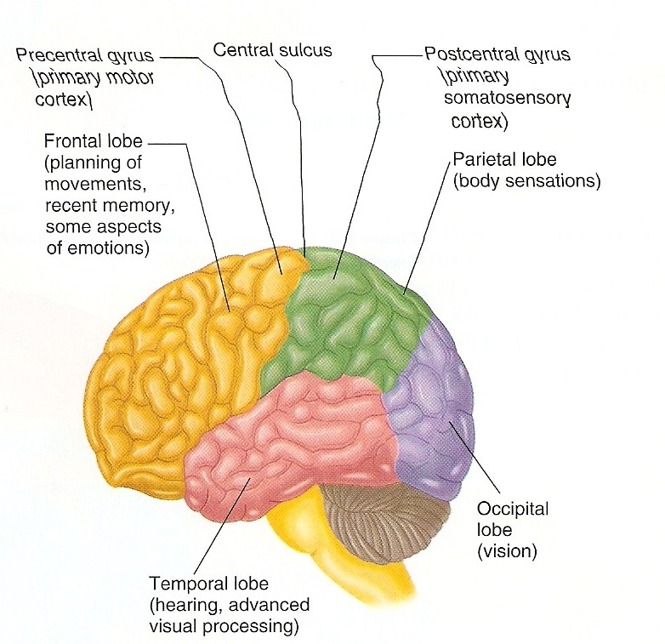
(Barlow and Durand , 2005)

Frontal Lobe (orange)

Located in the front of both cerebral hemispheres, the frontal lobes are the largest lobes of the brain. Anterior to the central sulcus (the groove that separates the frontal lobe and parietal lobe) is the primary motor cortex (homunculi), the centre for movement. Precise areas of the primary motor cortex represent particular areas of the body for example: the middle area of the cortex controls the legs, the lateral area is for the muscles of the face and largest area represented is for the arm and hands (located between both these areas). Also part of the motor cortex;
-Posterior parietal cortex ,responsible for transforming visual information into motor commands
-The pre-motor cortex ,responsible for motor guidance of movement and control of proximal and trunk muscles of the body.
-The supplementary motor area (or SMA)- responsible for planning and coordination of complex movements such as those requiring two hands.

A highly important part of the frontal lobe is Broca’s area. Broca’s area is involved in the motor production of speech. Damage to this area produces expressive aphasia (difficulty producing the motor movements of speech). The frontal lobes are also thought to be involved in complex functioning on the brain including personality, judgment, insight, reasoning, problem solving, abstract thinking and self evaluation termed executive functions. The Frontal lobe also has a function in working memory especially the ability to plan and initiate activity.

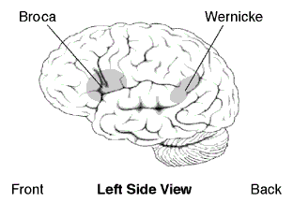
(http://www.nidcd.nih.gov/health/voice/aphasia.asp)

Parietal Lobes (green)

Located above the occipital lobes and behind the frontal lobes are the parietal lobes. Posterior to the motor cortex ( of the frontal lobes) is the somato-sensory cortex ( which receives general sensory information and initial reception of tactile (touch, pain, temperarture) and proprioceptive( sense of position) information. The other main role of the parietal lobes are complex aspects of special orientation and perception, and the comprehension of language function and the ability to recognise objects by touch, calculate, write, recognise fingers of opposite hands and organise spatial directions. The posterior areas of the parietal lobes (through the dorsal stream of the visual cortex) appear to link visual and somatosensory information together. Damage to these areas produces the neglect of entire spaces of sensory information for example only eating from one side of a plate and other sensory deficits.

Temporal Lobes (pink)

Located at the sides of the brain beneath the lateral or sylvian fissure, the temporal lobes are involved in receiving and processing auditory information, higher order visual information, complex aspects of memory, language and comprehension of language, abstract thought and judgement and control of written and verbal language skills. Wernike’s area is primarily responsible for comprehension of speech and closely linked with Broca’s area to produce speech. Damage to this area is associated with reduced thiamine levels due to alcohol abuse is characterised by diolopia, hyperactivity and delirium.

Occipital Lobe (blue)

Located at the rearmost portion of the brain, the occipital lobe is the main visual processing area of the cortex. The primary visual cortex, which receives raw sensory information from the retina processes information on colour, objects and facial recognition and is also involved in the perceiving motion. Damage to the visual cortex causes cortical blindness (all structures to see are intact but the person cannot receive the input from the sensors).

Corpus Callosum

The Corpus Callosum is the largest fiber bundle in the brain and connects the two hemispheres together. Allows for the transmission of information between the two hemispheres.

Diencephalon ( 2%of CNS)

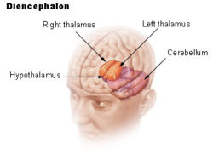
(http://training.seer.cancer.gov/module_anatomy/unit5_3_nerve_org1_cns.html)

Thalamus

The Thalamus is the main part of the Diencephalon and is located between the midbrain and cerebellum. All sensory pathways pass through the Thalamus and are relayed to various areas throughout the brain. The thalamus accomplishes this by filtering incoming information and deciding what to pass on or not to pass on to cortex, preventing the overload of sensory information. The Thalamus plays a role in mood and body movement associated with strong emotive responses such as fear or rage and also has some influence in prefrontal functions such as foresight and affect therefore its dysfunction has been implicated in abnormal behaviour.

Hypothalamus

The Hypothalamus can be viewed as the central control for the brain. It is located just below the thalamus, above the brain stem and is what keeps our body in homeostasis. Functions as the main control centre for the pituitary gland, regulating autonomic, emotional, endocrine and somatic function (body temp, arterial blood pressure, thirst, fluid balance, gastric motility and secretions), plays a part in ‘primitive’ states directly involved in stress related and psychosomatic illnesses, controls emotional and mood relationships, physical drive such as hunger and sex and co-ordinates our sleep/wake cycle.

Midbrain (mesencephalon)

Middle part of the brain, located at the upper part of the brain stem and connects to several major structures including the basal ganglia, substanitia nigra, pons and motor cortex making its exact function difficult to define.

Hindbrain (brainstem)

Metencephalon

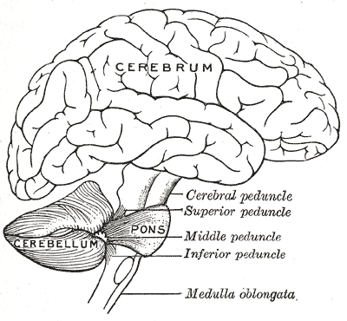
(Gray,????)

Cerebellum

The cerebellum or ‘little brain’ is located posterior to the brain stem and plays and important role in sensory perception and fine motor control. The Cerebellum has two main functions;
1) Receive input from all sensory sites and project this information to other parts of the brain such as the brainstem and thalamus.
2) Act as part of the motor system regulating equilibrium, muscle tone, postural control, and coordination of voluntary movement.
The Cerebellum is the part of the brain allows for fine movement, damage to the area results in poor coordination, poor motor learning, and a loss of equilibrium.

Pons

The pons is the main relay station between the cerebrum and the cerebellum. Majority of the brains norepinephrine is produced in the locus cerculeus located within the pons and aids in regulating arousal and respiration.

Myelencephalon

Medulla oblongata
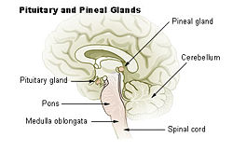
(http://training.seer.cancer.gov/module_anatomy/unit6_3_endo_glnds1_pituitary.html)

The Medulla acts as a conduction pathway for ascending and descending nerve tracks for the conscious control of skeletal muscles, balance, co-ordination, regulating sound impulses in the inner ear, regulating autonomic responses such as heart rate, breathing, swallowing, vomiting, coughing and sneezing.

Reticular formation

Functions as the central core of the brainstem. Most important in arousal and maintaining consciousness, alertness attention and our reticular activating system (RAS) which controls all cyclic functions such as Circadian Rhythm, cardiac rhythms and respiration. Damage to the RAS system can result in Coma, and this is the main area of the brain the anaesthetics suppressed to put someone to sleep. Stimulating this area results in arousal.

Basal Ganglia

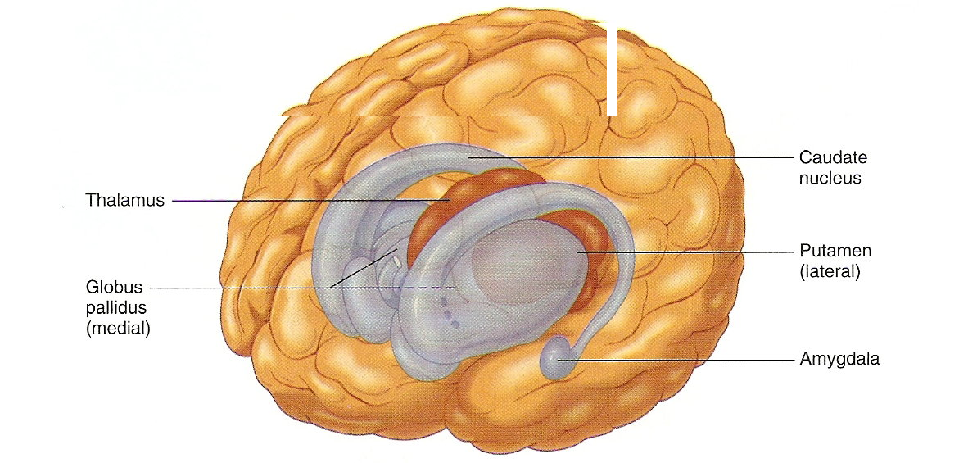
(Barlow and Durand , 2005)

The Basal Ganglia consists of several gray matter structures located in both sides of the brain in the cerebrum, diencephalon and midbrain. Main roles are to control muscle tone, activity, posture, large muscle movements and inhibit unwanted muscle movements. This is the main centre of the brain where EPSE’s and Parkinson’s symptoms originate due to loss of dopamine in the Substantia Nigra( the main dopamine producer in the brain) that is connected to basal ganglia.

The Limbic system

Located just above the thalamus and hypothalamus at the base of the forebrain is the limbic system. The limbic system is the ‘emotional centre’ of the brain. Components of the limbic system help to regulate our emotions, expression of emotion and ability to learn and control impulses.

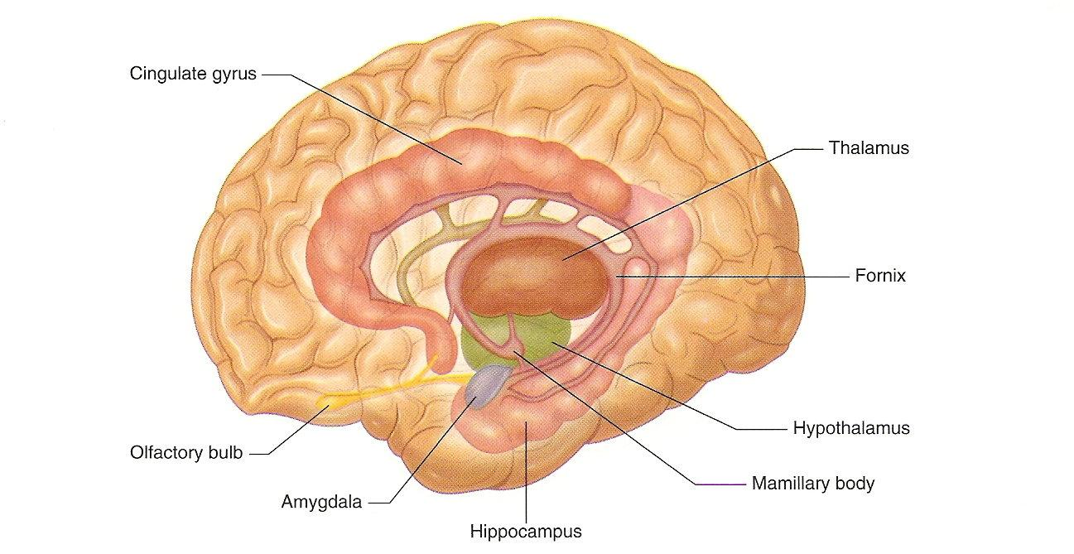
(Barlow and Durand , 2005)

Amygdala

Almond shaped structure located deep in the temporal lobe, connected to other parts of limbic system including the hippocampus and thalamus. Through these connections the amygdala mediates and controls major affective and mood states such as friendship, love, affection, fear, rage and aggression and generates these emotions from perceptions and thoughts. The amygdala is also the centre for which there are many opiate receptors. Studies of damage to this part of the brain in animals has a taming effect (deprivation of emotion, indifference), however stimulation elicits violent aggression.

Hippocampus

The Hippocampus is a part of the limbic system, and is located deep in the temporal lobe. The Hippocampus contains a large amount of neurotransmitters and its main functions appear to be memory, particularly turning short term memory into long term memory. Although the exact function of the hippocampus is unknown in Alzhiemers disease the Hippocampus is one of the major affected areas further suggesting its role in memory and orientation.

Protection and Blood supply

Within the skull that protects it, the brain also has several layers of prediction called meninges.
1. dura mater is the outer layer of protection (‘hard mother’) it is tough and inflexible.
2. pia mater is the inner layer of protection( ‘tender mother’) is a thin mesh like substance covering the brain.
3. Cerebral spinal fluid (CSF)- located within the space between the dura and pia mater ( called the arachnoid space).
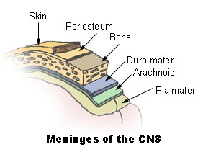
(http://training.seer.cancer.gov/module_anatomy/unit5_3_nerve_org1_cns.html)

CSF has two main functions

- Acts as a shock absorber. The brain floats in CSF lessening forcful shifting of the brain on movement.
- Mediates between blood vessels and brain tissue in exchange of nutrients

There are several Chambers within the brain that fill with CSF fluid.

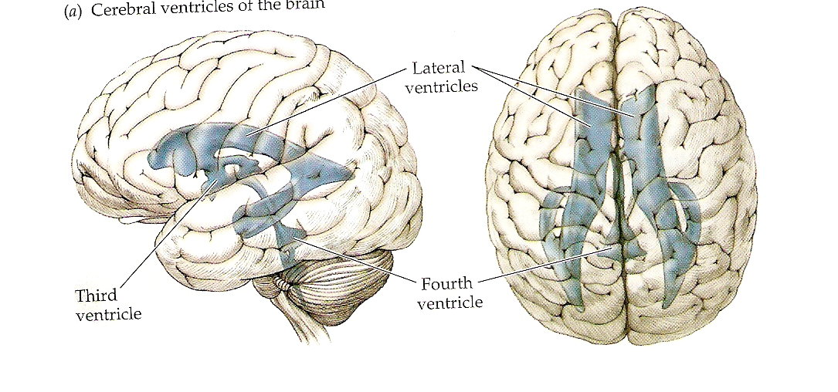

(Rosenweig, Breedlove and Leiman ,2005 pg 50 )

The brain is the hardest working organ of the body and therefore has strong metabolic demands. The brain vascular system needs to be large and efficient and serve these demands or else brain tissue will die. There are two channels in which the brain receives its blood supply

- The carotid arteries
Located on the left and right sides of the neck, these large vessels provide the blood supply to the largest parts of the cerebral hemispheres.

- The vertebral arteries forming into the Baliser atery
The vertebral arteries enter the brain at the base of the skull and give blood supply to the posterior portion of the brain.

At the base of the brain where the carotid and Basiler artery join is called the Circle of Willis.

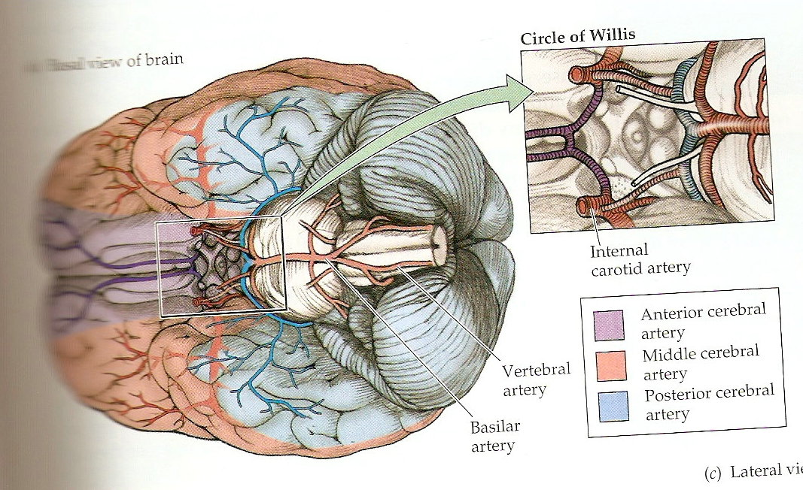

(Rosenweig, Breedlove and Leiman ,2005 pg 51 )

Blood Brain Barrier

The blood-brain barrier (BBB) is a membrane structure that acts primarily to protect the brain from chemicals in the blood, while still allowing essential metabolic function. The wall of the BBB is made up of endothelial cells with very tightly packed capillaries protecting the brain. Therefore, the brain needs to utilize other carriers in order to transport nutrients into the brain (i.e. glucose). The BBB means that that many drugs which are intended to treat central nervous system diseases have difficulty getting into the brain in the necessary quantity to be effective. Newer class of medications are attempting to facilitate greater absorption into the brain to treat disease such as Alzheimer’s and Parkinson’s disease.

Neurons and Synaptic Transmission

Structure of a neuron
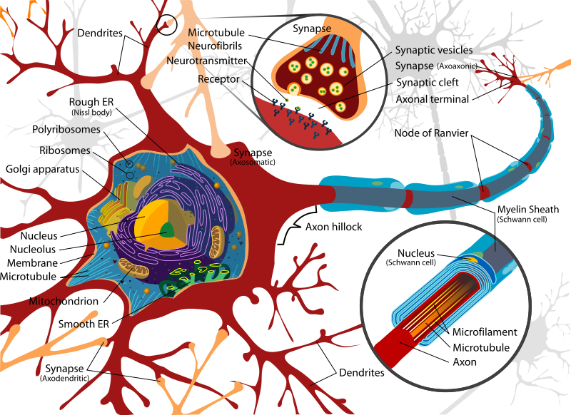
(This image has been released into the public domain by its author, LadyofHats. This applies worldwide.)

Major Definitions
Cell Body – Contains the cell nucleus and is the life blood of the cell.
Dendrites- The receptive surface of the neuron (receives information)
Axon- Carries nerve impulses from cell body to other neurons
Axon hilliock- Is where the nerve impulse originates
Axon terminal- Location of the synapse.
Myelin Sheath – Fatty insulation around an axon, acts to improve speed of production

Function of a neuron

Approximately 10 billion neurons are responsible for receiving, organising and transmitting information in the central nervous system. In order to relay this information to each cell, neurons utilise electrical impulses to communicate and activate adjacent cells. To explain how this process works we first need to review a few basics of electricity. Firstly, some molecules need to be net negatively charged (due to an abundance of electrons) and others net positively charged (due to few electrons) and when molecules are dissolved in fluid they are called ions. Ions in the intracellular fluid (inside the cell) have a negative charge attracting negatively charged cells (anions) whereas ions in extracellular fluid (outside the cell) have a positive charge attracting positively charged cells (cations), making a potential difference between the inside and the outside of the cell. Other forces that play a role in neuronal signalling are concentration gradient (Ions move from high concentration to concentration) and selective permeability (ability for ions to cross the cell membrane more readily than others).

The common Ions are sodium, potassium, calcium and chloride and all have specific molecular channels in which to pass through. The channels are ‘voltage gated’ meaning they open and close in response to changes in the electrical potential across the membrane. At rest the cells membrane potential is kept even by the distribution of potassium K+ and Sodium Na+ ions. Because the membrane is not impermeable to sodium Na+ small amounts of sodium can leak inside the cell. The sodium-potassium pump actively pumps Na+ out of the cells while replacing with K+ keeping the distribution even.
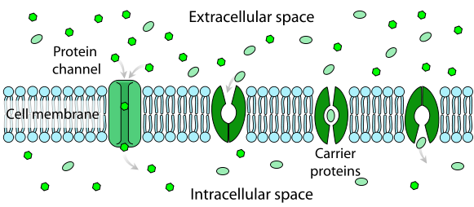
(This image has been released into the public domain by its author)

In order to produce an electrical signal along the axon, the cell needs to produce an action potential. An action potential is a brief change in neuronal polarization that travels rapidly along the axon ( i.e An electrical signal). An action potential occurs when the membrane of the cell becomes depolarised, that is the inner membrane surface becomes less negative in relation to the outer surface. This reaches a threshold (stimulus intensity that is adequate to trigger a nerve impulse) and then triggers the opening of the sodium channels allowing sodium to surge into the cell, creating a brief positive charge inside the cell and negatively charge outside the cell. After this occurs, potassium channels open repolarising the cell until all gates close and the cell returns to its resting potential.

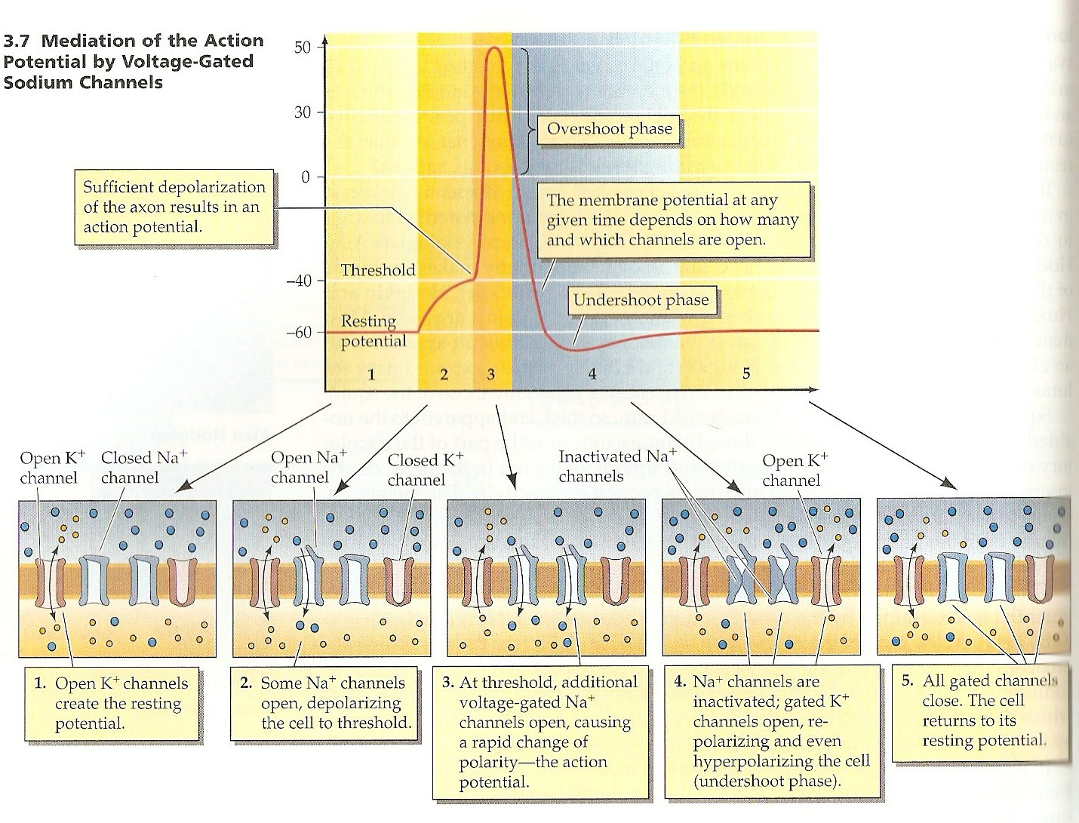

(Rosenweig, Breedlove and Leiman ,2005 pg 64 )

Synaptic Transmission

Synaptic transmission is the process in which nerve impulses move from one nerve cell to another. For one neuron to communicate with another neuron the electrical process previously described must change to a chemical communication. This occurs at the synaptic cleft, a junction between one nerve cell to another through substances called neurotransmitters. When an electrical impulse reaches the end of an Axon (terminals) calcium ion channels open stimulating the release of neurotransmitters into the synapse which are stored in small vesicles near the end of the axon. When stimulated (by the release of calcium into the cell) the vesicles fuse to the cell membrane and release into the synapse, crossing the synaptic cleft to a receptor site on the postsynaptic neuron 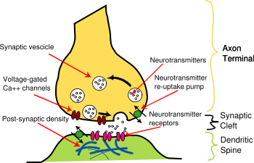

The receptors act as locks to for certain neurotransmitters i.e. dopamine receptors only lock onto dopamine neurotransmitters (the key) in the synapse. The receptor cell stimulated by a neurotransmitter then responds by producing its own action potential and either produce an action or act as a relay station sending the message through a pathway of neurons. When the neurotransmitter has completed its journey across the synapse it needs to be removed, this is done by being broken down by enzymes in the cleft or by reuptake back into the cell. Many pharmacological agents (i.e. antidepressants) block this process increasing the amount of neurotransmitter in the synapse available.

Neurotransmitters

Neurotransmitters are small molecules that control the opening and closing of ions channels in a cell.

Amines

Quaternary amines
Acetylcholine (ACh)

( Boyd, 2002)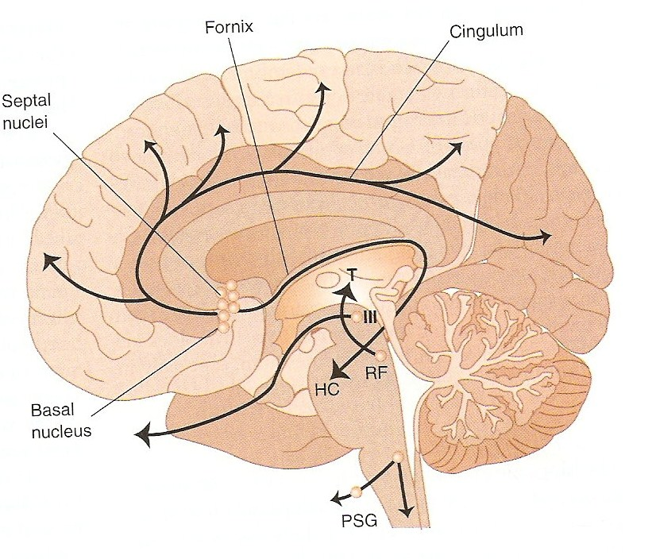

ACh was the first chemical substance to be known as a neurotransmitter. Neurons that produce and release ACh are termed Cholinergic and are released in the brain through cholinergic pathways. These pathways are concentrated in specific regions of the brain and are thought to be involved in cognition (esp. memory) and our sleep/wake cyle. ACh’s other important role is in the parasympathetic nervous system regulating bodily functions such as heart rate, digestion, secretion of saliva and bladder function. Damage to cholinergic pathways in the brain is thought to play a role in Alzheimer’s disease and myathesia gravis (weakness of skeletal muscles) and are thought to result from a reduction in ACh receptors in the brain. Blocking of ACh (for example by some antidepressants) cause what we know as anti-cholinergic effects such as dry mouth.

Role | Distribution | Role
M1 | Nerves | CNS excitation, gastric acid secretion
M2 | Heart, nerves, smooth muscle | Cardiac inhibition, neural inhibition
M3 | Glands, smooth muscle, endothelium | Smooth muscle contraction, vasodilation
M4 | ? CNS | Not known
M5 | ?CNS | Not known
NM | Skeletal muscles neuromuscular junction | Neuromuscular transmission
NN | Postganglionic cell body dendrites | Ganglionic transmission

( Lundbeck institute 2008, www.brainexplorer.org)

Monoamines

Catecholmines

Norepinephrine (NE)( also known as noradrenaline)

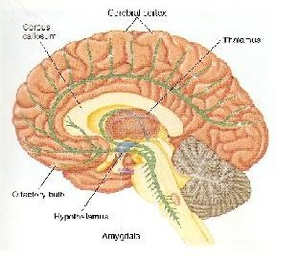
(Barlow and Durand ,2005)

NE (noradrenergic neurons) is found in 3 clusters in the brain: the locus coeruleus( makes NE), the pons, and reticular formation and projects to cerebral cortex, hippocampus, thalamus and midbrain. Noradrenergic pathways are thought to play an important role in attention, alertness and arousal. NE levels fluctuate with sleep and wakefulness and changes in attention and vigilance. Also thought to play an important role in regulating mood, affective states and anxiety. Some antidepressant medications block the reuptake of NE into the cell(SNRI’s) or inhibit monoamine oxidase from metabolising it( MAOI’s) increasing the levels of NE in certain pathways.

Dopamine

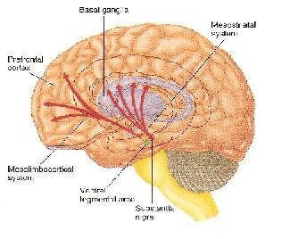
(Barlow and Durand , 2005)
Almost a million nerve cells in the human brain contain Dopamine. Dopamine is involved in the control of complex movement and cognition as well the control of emotional responses such as euphoria or pleasure (seen in amphetamine/cocaine use). The distribution of dopamine through the brain occurs through several pathways, the main two being the mesostriatal system and the mesolimbocortical system and are particularly involved in mental illness. The Mesostriatal system originates from the midbrain particulary the substantia nigra and striatum( claudate nulcleous and putamen). These pathways are thought to have significant role in motor control; degeneration of these systems can result in the resting tremors or paralyses seen in Parkinson’s disease due to a lack of dopamine. Blocking of this pathway through the use of antipsychotic medication results in extra-pyramidal side effects

Type | Distribution | Roles
D1, 5 | Brain, smooth muscle | Stimulatory, ? role in schizophrenia
D2, 3, 4 | Brain, cardiovascular system, pre-synaptic nerve terminals | Inhibitory, ? Role in schizophrenia

( Lundbeck institute 2008, www.brainexplorer.org)

Indoleamines

Serotonin (5HT)

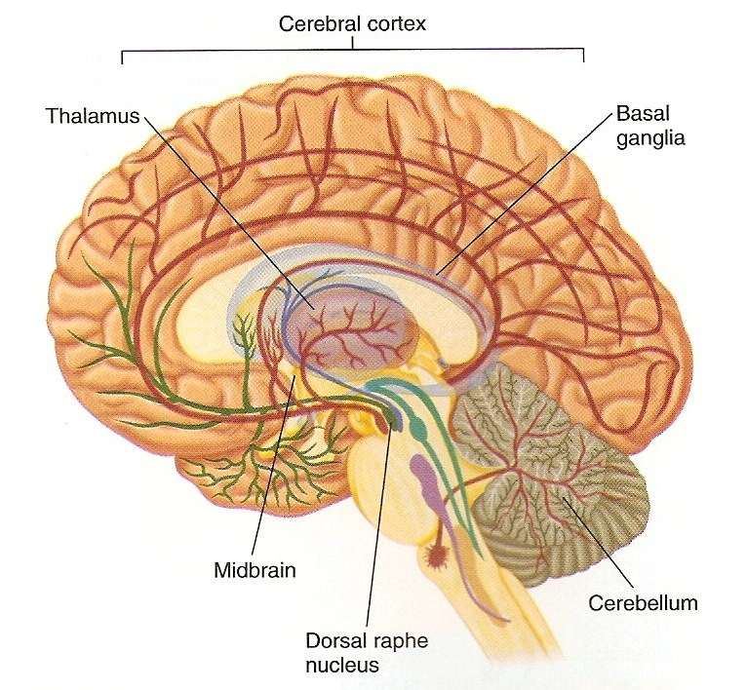
(Barlow and Durand, 2005)

There are approximately 6 pathways spreading from the midbrain that contain serotonin, many of these pathways end up in the cortex. Serotonin is believed to be one of the great influences on behaviour. Serotonin pathways regulate our behaviour, mood and thought processes. Serotonin is a complex neurotransmitter. Low serotonin activity is associated with aggression, suicide, impulsive eating and dis-inhibited sexual behaviour but this may only occur in certain receptors. Serotonin levels are also thought to play a role in modulating general activity levels of the CNS, particularly the onset of sleep. In mental illness serotonin plays a role in mood (depression and anxiety disorders), delusions, hallucinations and some negative symptoms of schizophrenia( LSD which produces some of these effects acts on serotonin receptors) There are at least 15 different 5HT receptors that we know of. Surprisingly the CNS only contains 2% of the bodies serotonin, the majority is found in the gastrointestinal tract (vasoconstriction).

Type | Distribution | Role
5HT 1 | Brain, intestinal cells | Neuronal inhibition, behavioural effects, cerebral vasoconstriction
5HT2 | Brain, heart, lungs, smooth muscle, GI system, blood vessels, platelets | Neuronal exhibition, vasoconstriction, behavioural effects, depression, anxiety
5HT3 | Limbic system, ANS | Nausea, anxiety
5HT4 | CNS, smooth muscle | Neuronal excitation, GI
5HT5, 6,7 | Brain | Not known

( Lundbeck institute 2008, www.brainexplorer.org)

Amino Acids

Glutamate

Glutamate is found in all cells of the body; in the CNS it is stored in synaptic vesicals and used as a neurotransmitter. Its function is to control the opening of ion channels that allow calcium to pass into nerve cells producing impulses. Blocking of glutamate receptors produces ( eg. By PCP) schizophrenic like symptoms leading to its implication in the illness. Over exposure of neurons to glutamate cause cell death seen in stroke and Huntington’s disease (PN).

Gamma-aminobutyric acid (GABA)

GABA is derived from glutamate and its receptors can be found in most neurons of the brain. Its major effect is inhibitory and its pathways are only found within the CNS, the largest concentration in the hypothalamus, hippocampus, basal ganglia, spinal cord and cerebellum. Its major role is to control excitatory neurotransmitters in the brain and controlling spinal and cerebral reflexes. Dysregulation of GABA has implications in anxiety disorders and decreased GABA can lead to seizure activity. Benzodiazepines and barbiturates sedative medication act on GABA receptors in the brain.

References

Boyd (2002). Psychiatric Nursing , contemporary practice .Lippincott, USA

Rosenweig, Breedlove and Leiman (2002) Biological Psychology: an introduction to cognitive, behavioural and clinical neuroscience 3rd Edition.Sineur Associates , Inc USA.

Stuart and Laraia (2005) Prinicples and Practice of Psychiatric Nursing. Mosby, USA.

Barlow and Durand (2005). Abnormal Psychology, and intergrated approach.Thompson/Wadsworth, Australia.

Leonard BE (1997). Fundamentals in Psychopharmacology. 2nd ed. Chichester: Wiley & Sons.
Purves DE, Augustine GJ, Fitzpatrick D, et al. (eds). Neuroscience. Sunderland, MA: Sinauer Associates, Inc; 1997.
Lundbeck Institute, www.brainexplorer.com

Blakemore & Frith (2005). The Learning Brain. Blackwell Publishing
Hauk O, Johnsrude I, Pulvermuller F (2004). "Somatotopic representation of action words in human motor and premotor cortex". Neuron 41 (Jan. 22): 301-307.

Begley (2005). The blood brain Barrier. Gauchers News May 2005c

